REVISED QUICK COGNITIVE SCREENING TEST, (RQCST)

Name: ID/No.:

Sex: Handedness: Diagnosis:

Age: Date of birth:

Highest level of education completed:

Occupation:

Date tested: Time tested: AM / PM

Test given by:
General Comments:

Tester’s Signature:

Mate-Kole, C.C., Conway, J., Catayong, K., Bieu, R., Sackey, N.A., Wood, B. & Fellows, R.
(2009).Validation of Revised Quick Cognitive Screening Test. Archives of Physical and Medical Rehabilitation, 90, 1469- 1476

ORIENTATION
- What time of day is it?

- What day of the week is this?

- What month is this?

- What date of the month is this?

- What year is this?

- Where are you now?

- What is your age?
- What is your date of birth?

- What is the name of the President?

- Who was the President before him/her?

- Write or say all the days of the week.

- Write or say your full address.

ORIENTATION  Total Score (items 1 – 12, one point each) __________ |  |  | Maximum score 12

ATTENTION / CONCENTRATION (VERBAL)
13. I want to see how quickly you can count by threes, beginning with one, like this:
1, 4, 7, etc.

1, 4, 7, 10, 13, 16, 19, 22, 25, 28, 31, 34, 37, 40

Errors: circle errors and record actual response.

Scoring: All correct = 2 points. One error = 1 point. Two or more errors = 0 points.
ATTENTION/CONCENTRATION (VERBAL)  Total Score (item 13) __________ | Maximum score 2
ATTENTION / CONCENTRATION (VISUAL)  14. How many dots are there in each set shown?  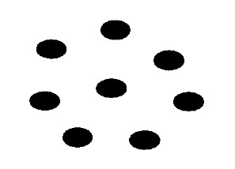  Number of dots | 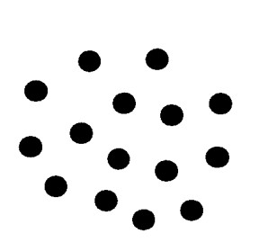  Number of dots
ATTENTION/CONCENTRATION (VISUAL)  Total Score (item 14, one point each) __________ | Maximum score 2

MEMORY: IMMEDIATE RECALL (VERBAL)
15. I am going to name some objects. When I am finished I want you to say them back to me.
pen watch tie car book

I want you to remember these words because I will ask you to repeat them back to me later.

MEMORY: IMMEDIATE RECALL (VERBAL)  Total Score (item 15, one point each) __________ |  |  | Maximum score 5

SPATIAL NEGLECT

- Make a stroke through the middle of each line.

SPATIAL NEGLECT  Total Score (item 16, one point per correct marking) __________ |  | Maximum score 4

ARITHMETIC:

- Do these arithmetic problems:
____
113 65 20 12)144
+113 -56 x 3

ARITHMETIC  Total Score (item 17, one point each) __________ |  |  |  |  |  | Maximum score 4

CONSTRUCTIONAL PRAXIS
18. Copy this drawing:

Scoring: one point for each figure; one point for correct placement of each figure
CONSTRUCTIONAL PRAXIS  Total Score (item 18) __________ |  |  |  |  | Maximum score 6

MEMORY: IMMEDIATE RECALL (VISUAL)
19. Draw the same figures again.

Scoring: one point for each figure; one point for correct placement of each figure
MEMORY: IMMEDIATE RECALL (VISUAL)  Total Score (item 19) __________ |  |  |  | Maximum score 6

VOCABULARY

Circle the word in the group which means the same as the word in capital letters above the group, as in the example.

Example: EQUAL

Excellent Uneven

Average Same

Copy

20. DELICATE 21. CAUTION

Flexible Tough Vigil Neglect

Decompose Fragile Courage Care

Touch Despair

22. ALLOW 23. PARTICLE

Permit Forbid Piece Full

Refuse Help Partial Point

Fallow Complete

24. REGENERATE

Erect General

Live Restore

New

VOCABULARY  Total Score (item 20 - 24, one point each) __________ |  |  |  | Maximum score 5

NAMING

Name or write the names of these items:

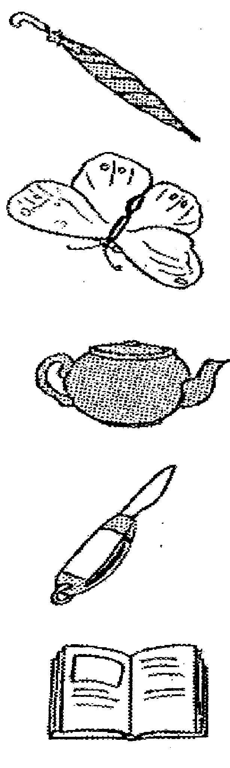
- ______________________________
- ______________________________
- ______________________________
- ______________________________
- ______________________________

NAMING  Total Score (items 25 – 29, one point each) __________ |  |  | Maximum score 5

ABSTRACT REASONING: SIMILARITIES

Circle one word or phrase on the right which describes both the words on the left.
Example:
Banana & Orange Round Color Taste Fruit Buy Them

- Knife & Fork Plate Out Spoon Cutlery Eat

- Salt & Sugar Drink Grow Taste Smell them Eat them

- Ruler & Scale Drawing Cooking Weighing Straight Measuring

- Nose & Tongue On Face Taste Talking Sense Organs For eating

ABSTRACT REASONOING: SIMILARITIES  Total Score (items 30 – 33, one point each) __________ |  |  | Maximum score 4

ABSTRACT REASONING: ANALOGIES

Circle the word which completes the sentence.
Example:
Big is to Small as Large is to:

Enormous Short Huge Narrow Little

- Hand is to Glove as Foot is to:

Hat Cold Leg Shoe Coat

- Spider is to Web as Bird is to:

Nest Egg Tree Fly Wing

- Sun is to Heat as Lamp is to:

Flower Light Star Shadow Fire

- Spring is to Summer as Tuesday is to:

Wednesday Saturday Thursday Monday Friday

ABSTRACT REASONING: ANALOGIES  Total Score (items 34 – 37, one point each) __________ |  |  | Maximum score 4

UNUSUAL VIEWS
Identify or write the names of these objects:
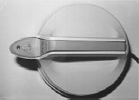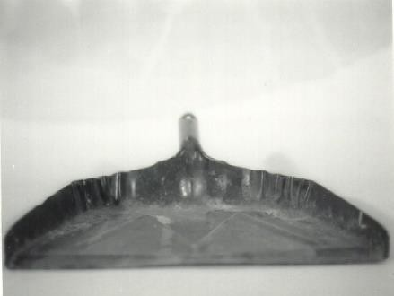

38. _________________________ | 39. _________________________
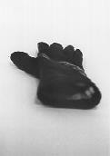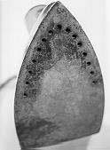
40. _________________________ | 41. _________________________
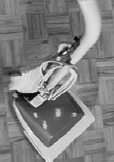
42. _________________________
UNUSUAL VIEWS  Total Score (items 38 – 42, one point each) __________ |  |  | Maximum score 5

SPATIAL ORIENTATION
Point or underline the design on the right which is the same as the design on the left.
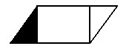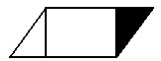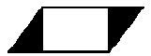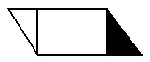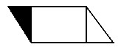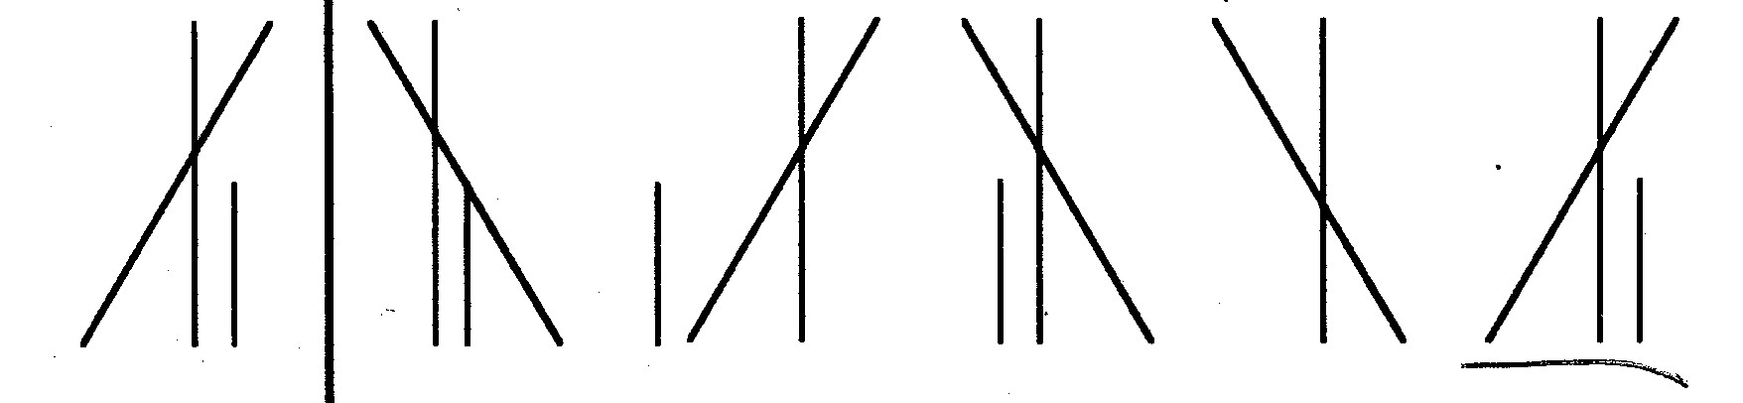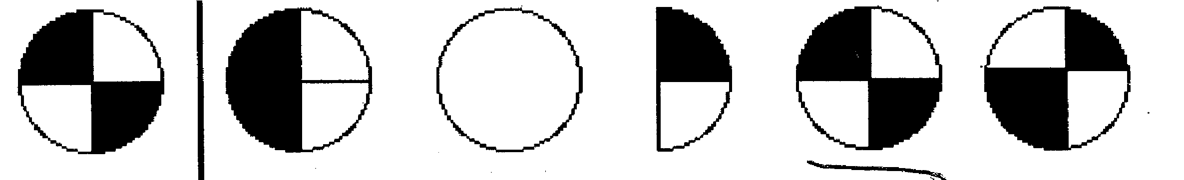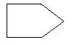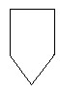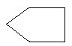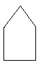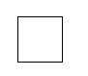
45.

46.

47.

Example:

43.

-
A
-

-
B
-

-
C
-

-
D
-

-
E
-

44.

-
A
-

-
B
-

-
C
-

-
D
-

-
E
-

SPATIAL ORIENTATION  Total Score (items 43 - 47, one point each) __________ |  |  | Maximum score 5

MEMORY: DELAYED RECALL (VISUAL)
48. I want you to draw the figures that you drew earlier.

Scoring: one point for each figure; one point for correct placement of each figure.
MEMORY: DELAYED RECALL (VISUAL)  Total Score (item 48) __________ |  |  |  | Maximum score 6

MEMORY: DELAYED RECALL (VERBAL)

49. I want you to repeat back to me the five objects I named earlier.

MEMORY: DELAYED RECALL (VERBAL)  Total Score (item 49, one point each) __________ |  |  |  | Maximum score 5

MEMORY: NEW LEARNING
50. I am going to say a sentence to you. Listen carefully and when I am finished I would like you to repeat the sentence back to me exactly as I say it to you.

◻ (Tester Note: Repeat sentence up to 10 trials. Stop if testee obtains exact response.) ◻

“One thing a nation must have to be rich and great is a large secure supply of wood.”

Trials: 1 2 3 4 5 6 7 8 9 10 >10
Score: (10) (9) (8) (7) (6) (5) (4) (3) (2) (1) (0)

MEMORY: NEW LEARNING  Total Score (item 50) __________ |  |  |  |  | Maximum score 10

REVISED QUICK COGNITIVE SCREENING TEST, (RQCST) Summary of Scores

Name: ID/No.:

Orientation
1 -12 Orientation / 12

Verbal Tests
13 Attention / Concentration (Verbal) / 2
15 Memory: Immediate Recall (Verbal) / 5
17 Arithmetic / 4
20–24 Vocabulary / 5
25–29 Naming / 5
30–33 Abstract Reasoning: Similarities / 4
34–37 Abstract Reasoning: Analogies / 4
- Memory: Delayed Recall (Verbal) / 5
- Memory: New Learning / 10
Verbal Score |  | / 44
Visual /  14  16  18  19  38–42  43-47  48 | Spatial / Constructional Tests  Attention / Concentration (Visual)  Spatial Neglect  Constructional Praxis  Memory: Immediate Recall (Visual)  Unusual Views  Spatial Orientation  Memory: Delayed Recall (Visual) | / 2  / 4  / 6  / 6  / 5  / 5  / 6
Visual / Spatial Score |  | / 34
GLOBAL SCORE |  | / 90

Tester’s Signature: Scoring Date:

